**Python 3.6.8 installation**

**Version 1.0**

**Version History**

|  |  |  |  |
| --- | --- | --- | --- |
| **Version** | **Date** | **Handled by** | **Comments** |
| V1.0 | 17-May-2019 | ZL Chen | First version release. |
|  |  |  |  |

Precondition Setting:

Please make sure the DUT is connected to the internet.

Please follow the installation steps as below:

Step 1:

Please find the “Sikuli-X-1.0rc3 (r905)-win32.exe” under the installer folder, and then double click this one.

Location: .\automation\installer

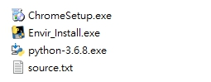

Step 2:

Please tick the checkbox, and then click the “Customize installation” option.

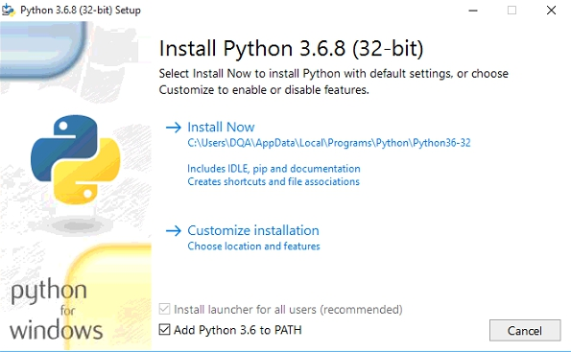

Step 3:

Please click the “Next >” button.

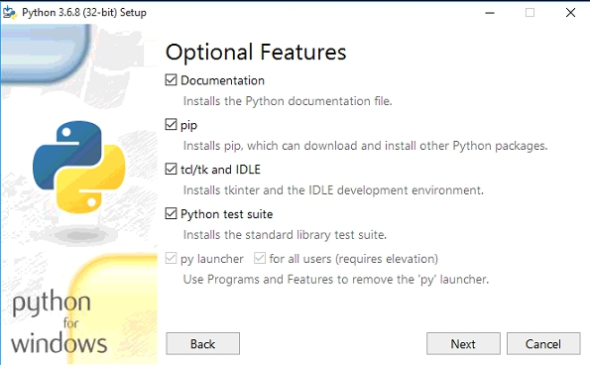

Step 4:

Please tick the “Install for all users” and “Precompile standard library” checkbox.

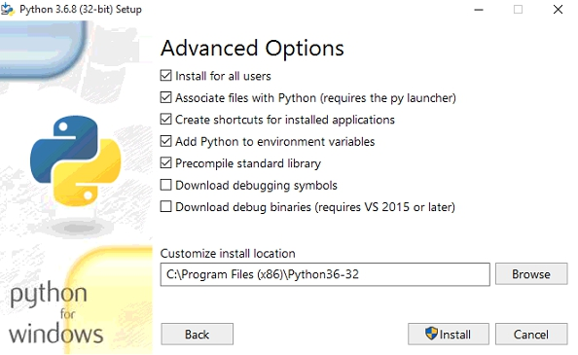

Step 5:

Please modify the install location to “C:\Python36”, and then click “Install” button.

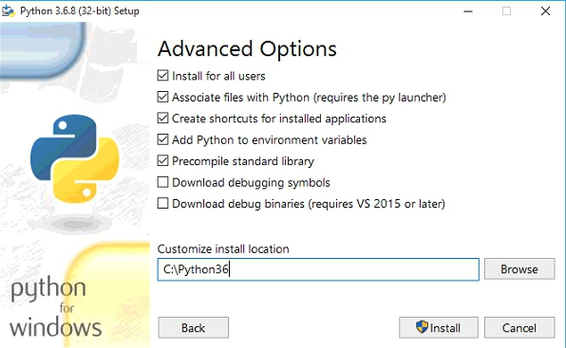

Step 6:

The python 3.6.8 is completed.

Click the “Disable path length limit” and “Close”.

